Cairo University  
Faculty of Computers and Information



**CS251**

**Software Engineering I**

## GeniuStack

Software Design

## Dina Abdelhakam Qubese

## Radwa Khaled Attia

## Abdelrahman Mamdouh

## Abdelrahman Nasser

December-2016

Contents

GeniuStack 1

Dina Abdelhakam Qubese 1

Radwa Khaled Attia 1

Abdelrahman Mamdouh 1

Abdelrahman Nasser 1

Instructions [To be removed] 3

Team 3

Document Purpose : 3

Audience: 3

System Models 4

I. Class diagrams 4

II. Sequence diagrams 6

1)PlayGame: 6

2)AddGame: 7

3)Registration: 8

Class - Sequence Usage Table 8

Ownership Report 9

We worked as a team in every single detail. 9

Policy Regarding Plagiarism: 9

# Team

|  |  |  |  |
| --- | --- | --- | --- |
| **ID** | **Name** | **Email** | **Mobile** |
| 20140113 | Dina Abdelhakam Qubese | dinaabdelhakam1997@gmail.com | 01117397855 |
| 20140119 | Radwa Khaled Attia | radwakhaled41@gmail.com | 01069071133 |
| 20140164 | Abd El-Rahman Mamdouh Mohamed | abdobelal201015@gmail.com | 01065142541 |
| 20140165 | Abd El-Rahman Nasser Ali | a.nasser07@hotmail.com | 01128265428 |

# Document Purpose :

Our Purpose is to provide details for both the class diagram and the Sequencediagram of the website as it is an interaction diagram that shows how objects operate with one another and in which order.

# Audience:

The audience for this software design document includes the TAs, designers, developers, client and the user.

# 

# System Models

## I. Class diagrams

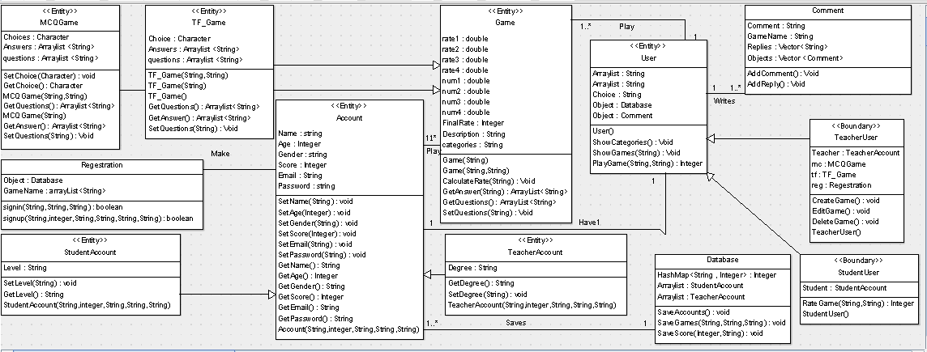

| **Class ID** | **Class Name** | **Description & Responsibility** |
| --- | --- | --- |
| 1 | Registration | Responsible for Registration on the website and getting information about the user and verification of the mail address. |
| 2 | Account | It contains user information such as Name, Age, Gender…etc. |
| 3 | TeacherAccount | It’s a special case of the class account related to teachers’ as they can create ,edit or delete game. |
| 4 | StudentAccount | It’s a special case of the class account related to as students’ as they can rate game. |
| 5 | Game | Contains full information about games related to the website such as a small description about the game ,name and owner. |
| 6 | MCQ | Special case of games which is multiple choice questions as the student can play by choosing the correct answer from list of choices. |
| 7 | True&False | Special case of games which is True Or False as the student can play by choosing whether the statement is true or not. |
| 8 | User | It’s a boundary class shows the boundaries for the users’ as it shows what the system offers for its users. |
| 9 | TeacherUser | Special type of class user that shows boundaries for user teacher as they can create games…etc. |
| 10 | StudentTeacher | Special type of class user that shows boundaries for user student as they can rate games…etc. |
| 11 | Comment | This Class for saving the user Comment and enables the user to write a reply for a specific comment |
| 12 | Database | Database class its where the data related to the user and the games are saved in. |

## II. Sequence diagrams

# 1)PlayGame:

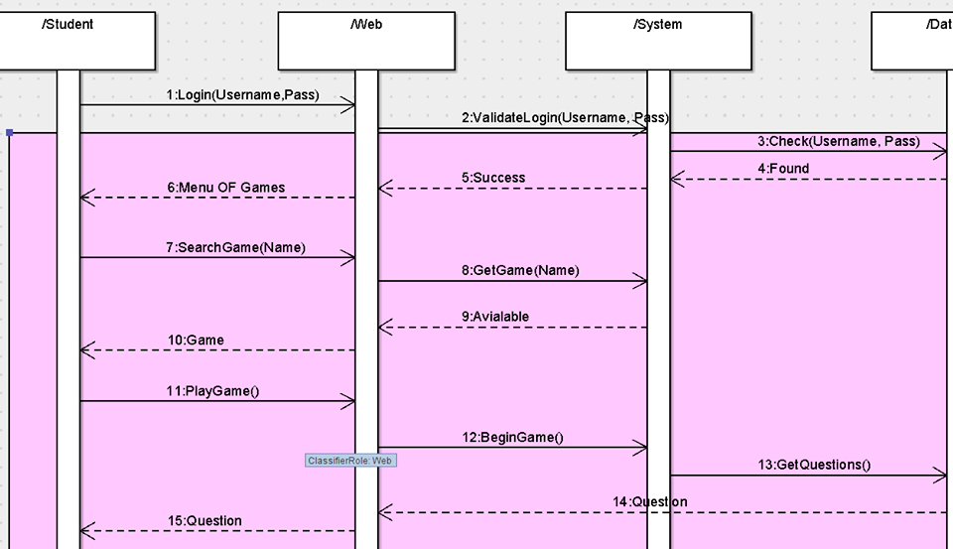

# 

# 2)AddGame:

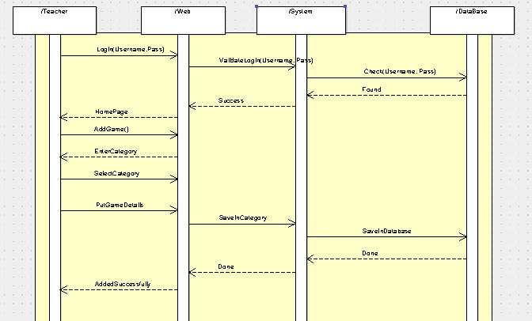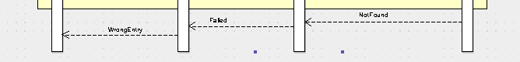

# 3)Registration:

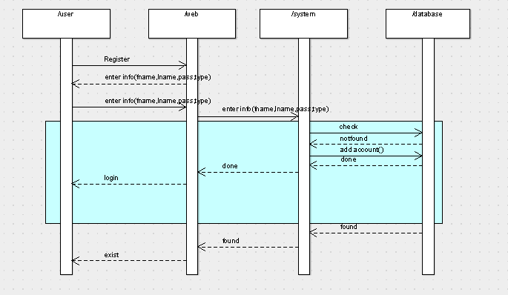

### Class - Sequence Usage Table

| **Class Name** | **Sequence Diagrams** | **Overall used methods** |
| --- | --- | --- |
| User | 1,6 (Add Game Seq)  1 (Registration Seq)  1,8 (Play Game Seq) | Save & Load |
| Registration | 5 (Registration Seq)  2,3 (Play Game Seq) | Check & Exit |
| TeacherUser | 7,9 (Add Game Seq)  7,11,21 (Play Game Seq) | Add, Edit, Delete, Save, Load, Write, Show & Exit |
| StudentUser | 7,11,21 (Play Game Seq) | Save, Load, Write, Show & Exit |
| DataBase | 7 (Registration Seq)  20,23 (Play Game Seq)  15 (Add Game Seq) | Save & Load |
| Game | 13 (Play Game Seq) | Calculate & Get |
| Registration | 2,3 (Play Game Seq)  2,3 (Add Game Seq) | Check |
| MCQ | 17 (Play Game Seq) | Set & Get |
| True&False | 17 (Play Game Seq) | Set & Get |

# Repository link

https://github.com/Dina1997/GeniuStack.git

# Ownership Report

We worked as a team in every single detail.

# Policy Regarding Plagiarism:

1. تشجع الكلية على مناقشة الأفكار و تبادل المعلومات و مناقشات الطلاب حيث يعتبر هذا جوهريا لعملية تعليمية سليمة
2. ساعد زملاءك على قدر ما تستطيع و حل لهم مشاكلهم فى الكود و لكن تبادل الحلول غير مقبول و يعتبر غشا.
3. أى حل يتشابه مع أى حل آخر بدرجة تقطع بأنهما منقولان من نفس المصدر سيعتبر أن صاحبيهما قد قاما بالغش.
4. قد توجد على النت برامج مشابهة لما نكتبه هنا أى نسخ من على النت يعتبر غشا يحاسب عليه صاحبه.
5. إذا لم تكن متأكدا أن فعلا ما يعد غشا فلتسأل المعيد أو أستاذ المادة.
6. فى حالة ثبوت الغش سيأخذ الطالب سالب درجة المسألة ، و فى حالة تكرار الغش سيرسب الطالب فى المقرر.